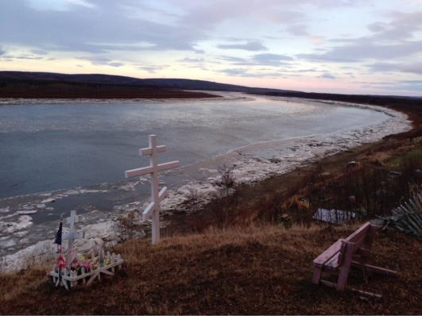
Our land is home to many different forms of life and to our way of life.
It is important how we keep it to maintain our traditions

This Tribal Response Program is our opportunity to inventory, assess, and clean up our environment.
 | 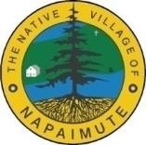
BOX HOLDER or CURRENT RESIDENT  General Delivery Aniak, AK 99557 | Native Village of Napaimute on Facebook Napimute.org
Native Village of Napaimute PO Box 107  Aniak, AK 99557 | Land Line (907)675-4388  Napaimute.brownfields@gmail.comm

Native
Village of Napaimute
Brownfields Tribal Response Program
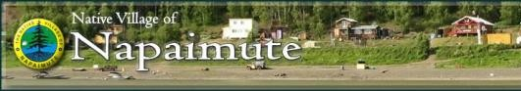

This program, and its associated Brownfield component, will allow the Native Village of Napaimute to immediately locate and inventory potentially hazardous sites that directly affect us and any communities downstream.
For more information contact:
Joe Kameroff, napaimute.brownfields@gmail.,com (907)675-4388

What is a Brownfield

- Real property where expansion, redevelopment, or reuse of the property may be complicated by the presence or the potential presence of hazardous substance, pollutant, or contaminant. As defined by The Environmental Protection Agency (EPA)

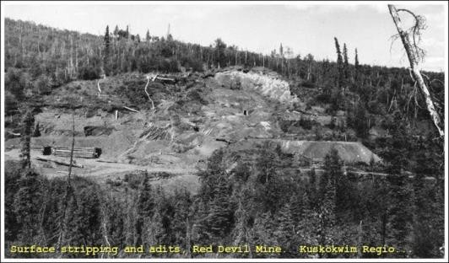
Old mine sites, dumpsites, military sites, abandoned tank farms, buildings that may have or had a controlled substance are examples of potential brownfield site.

Goals & Objectives

Property Redevelopment:  Rehabilitated Subsistence Areas  Gardens Trails Parks Housing  Community Center And many others | 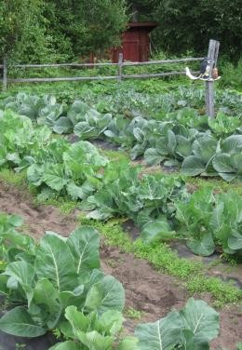

Benefits of Brownfields Redevelopment

Protect human health and environment Increase property value
Reuse of existing infrastructure Improve quality of life
Wildlife habitat rehabilitation

Substances that maybe present in Alaska

Gasoline, Diesel, Asbestos, Lead, Pesticides, Solvents, PCBs, and many more

Native Village of Napaimute can help with

- Be a resource – Inventory Potential Sites
- Educate – Help assist with training for response as needed
- Assist – Help high priority sites with assessment for possible clean up.

Additional Benefits

- Historic Preservation

- Economic Development

- Community Development

